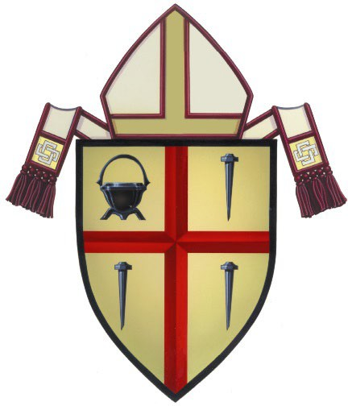

# IRA CHARITABLE ROLLOVER INSTRUCTIONS/REQUIRED MINIMUM DISTRIBUTIONS (RMD)

“The Internal Revenue Service reminds individual retirement arrangement (IRA) owners age 70½ and older that they can make up to $108,000 in tax-free charitable donations during 2025 through qualified charitable distributions. That’s up from $100,000 in past years.

For those age 73 or older, qualified charitable distributions (QCDs) also count toward the year's required minimum distribution (RMD).”

The Charitable IRA Rollover or QCD allows you to make a direct distribution from your IRA account to the Diocese of San Diego to benefit your favorite ministries including your parish, school, Annual Catholic Appeal (ACA), Catholic Charities, Catholic Community Foundation, Office for Missions and various ministries. The following conditions apply: **(1) you must be age 70½ or older at the time your distribution is made, and (2) there is a limit of $108,000 per individual per year that can be excluded from gross income. If you file a joint return, you and your spouse each have a $108,000 exclusion limit totaling $216,000. (3) The transfer of funds must be made directly by your IRA plan administrator to the Diocese of San Diego.**

**Who? Donors who are at least 70½ years of age or older at the time of distribution and have an IRA.**

**What?** An individual owner of an IRA may instruct their IRA manager to distribute any amount up to $108,000 directly to the Diocese of San Diego for the benefit of a specific ministry or Catholic entity in the Diocese of San Diego without the distribution being included as taxable income. The distribution will then count toward the IRA owner’s required minimum distribution (RMD).

**How?** Contact your IRA representative to arrange for the proper transfer of funds from your IRA directly to the Diocese of San Diego. Please use the attached form to request the transfer. The check issued from your IRA must be made payable to the Diocese of San Diego. The transfer of your IRA distribution must be made directly by your plan administrator to the Diocese of San Diego by December 15 to allow adequate time for processing and to qualify for that tax year.

[For further information, please contact](https://www.sdcatholic.org/giving/ira/) the Diocese of San Diego at 858-490-8294 or [maguilar@sdcatholic.org](mailto:maguilar@sdcatholic.org) or visit [https://www.sdcatholic.org/giving/ira/](http://www.sdcatholic.org/giving/ira/)

**Mailing Address:**

**Diocese of San Diego Pastoral Center**

**P.O. Box 85728**

**San Diego, CA 92186-5728**

DISCLAIMER: The Diocese of San Diego does not provide tax, legal or accounting advice. This material has been prepared for informational purposes only, and is not intended to provide, and should not be relied on for, tax, legal or accounting advice. Please consult with your own personal tax advisor for professional advice before engaging in any transaction.

Diocese of San Diego, P.O. Box 85728, San Diego, CA 92186-5728 Phone: 858-490-8294 Fax 858-490-9272 [https://www.sdcatholic.org/giving/ira/](http://www.sdcatholic.org/giving/ira/)



# IRA ROLLOVER INSTRUCTIONS TO PLAN ADMINISTRATOR

**TO: Your IRA Plan Administrator:** Click here to enter text.

**FROM: Plan Owner/s:** Click here to enter text.

**ADDRESS:** Click here to enter text.

**EMAIL: PHONE:** Click here to enter text.

**ACCOUNT #:** Click here to enter text. **DATE:**

**RE: Request for Charitable Distribution from Individual Retirement Account**

As the owner of IRA account [Click here to enter text.] that is in the custody of your organization, I request that you transfer from that account the sum of: [**$ Click here to enter text.**]

Please issue a check in the amount of $ Click here to enter text. payable to:

**Diocese of San Diego**

**For the benefit of:** Click here to enter text.

**(Please specify parish, school, ministry or ACA)** Click here to enter text.

**(If intended for your Annual Catholic Appeal gift, please include ACA Constituent ID if possible)**

Please mail check to: **Diocese of San Diego, Attn: Manny Aguilar**

Diocese of San Diego, P.O. Box 85728, San Diego, CA 92186-5728 Phone: 858-490-8294 Fax 858-490-9272

Please accept this form as my request to make a direct charitable distribution from my IRA. In your transmittal to the charity, please memorialize my name and address as the donor of record in connection with the transfer. Please copy me on your transmittal.

If you have any questions or need to contact me, I can be reached at the information listed above. Thank you for your assistance in this matter.

Sincerely,

Signature Date

Diocese of San Diego, P.O. Box 85728, San Diego, CA 92186-5728 Phone: 858-490-8294 Fax 858-490-9272 https://[www.sdcatholic.org/giving/ira/](http://www.sdcatholic.org/giving/ira/)